2-4 Activity: GNS3 Sandboxing Part One
Andree Salvo
Southern New Hampshire University
Cyb 220
Instuctor: Wesley Buchan
2025
Note: If you see my “name” where the command prompt is, it just shows you that it is proof of my work.
- Create the network and submit a screenshot of the topology, which should include the configuration described below. | 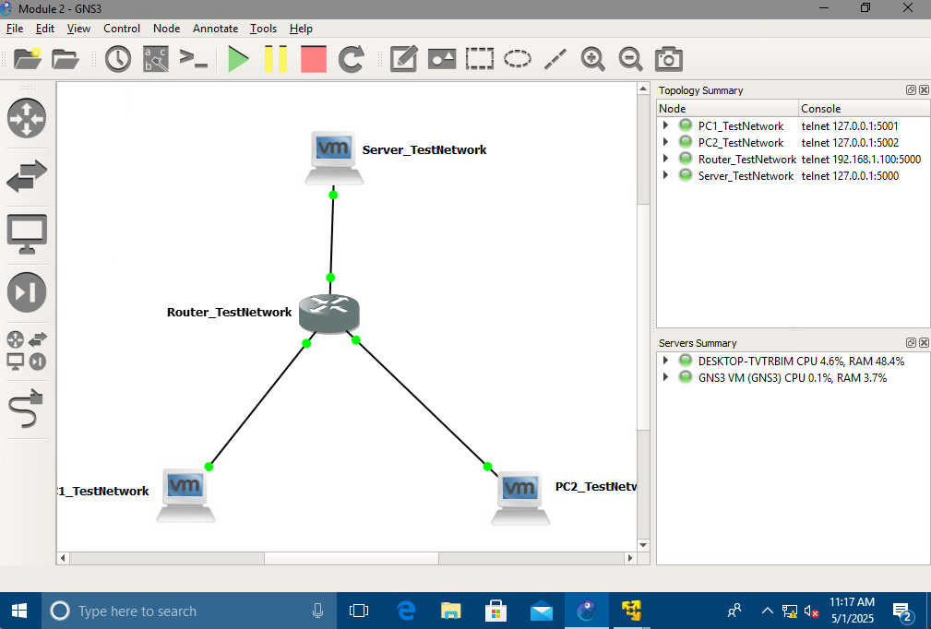
Connect two Windows PCs (labeled PC1_TestNetwork and PC2_TestNetwork) to the router and assign IP addresses as indicated in the table provided. | 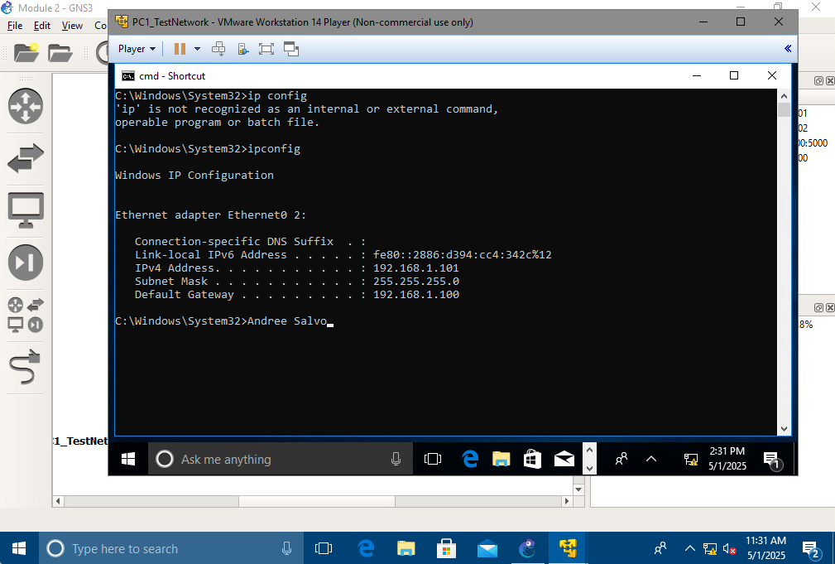
PC2_TestNetwork: | 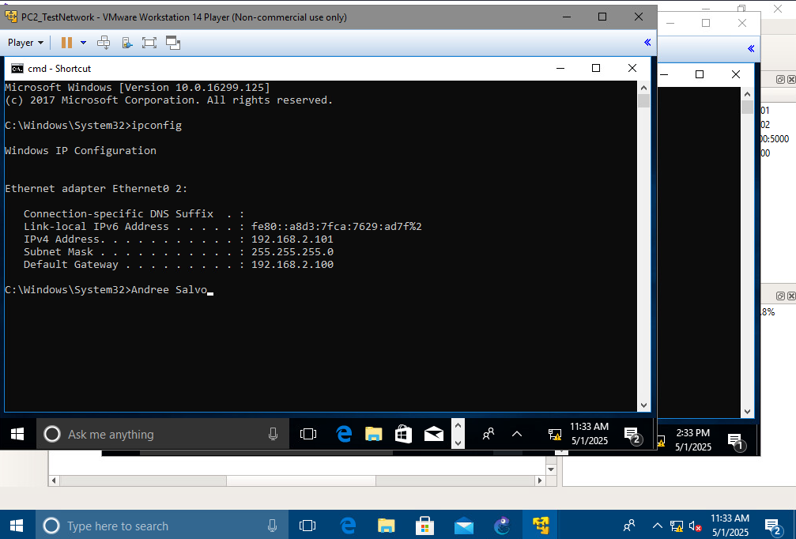
Connect the Windows server (labeled Server_TestNetwork) to the router and assign an IP address as indicated in the table provided. | 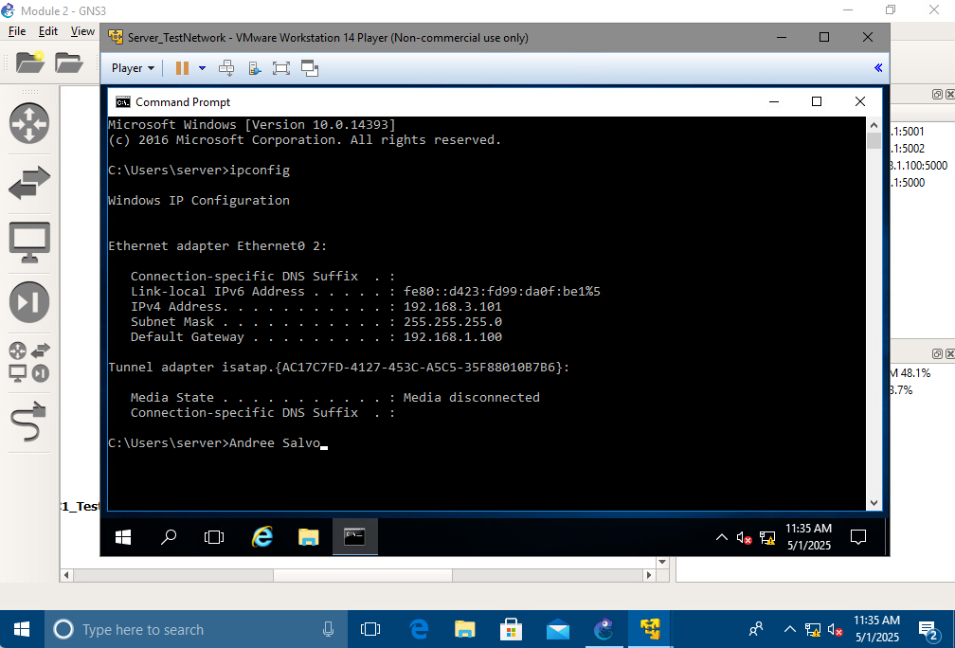
Configure the Cisco 3745 router (labeled Router_TestNetwork) and assign IP addresses on the interfaces as indicated in the table provided. | 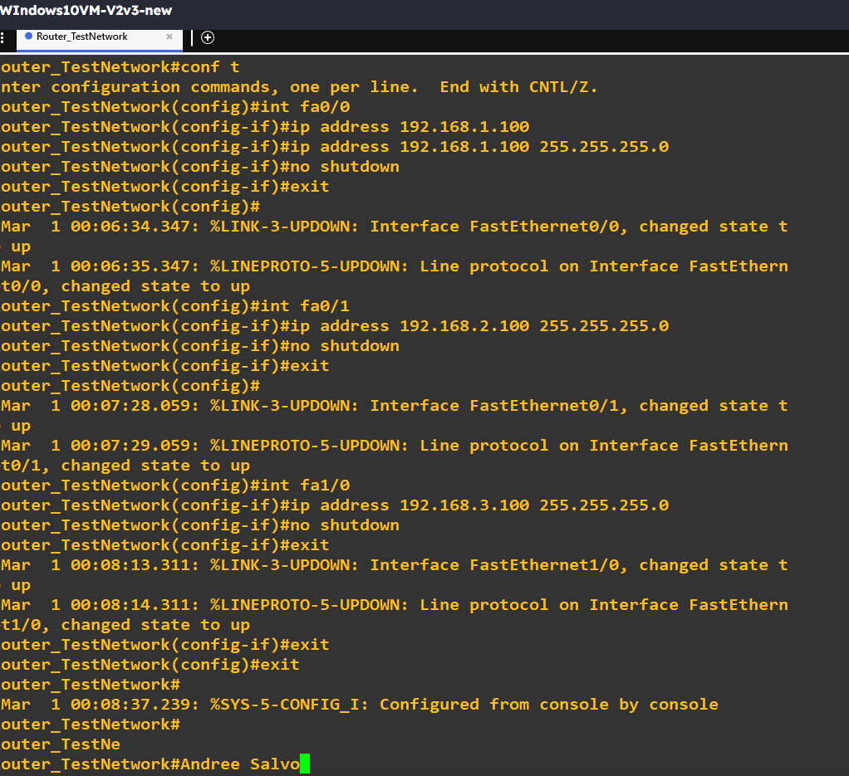

- Test connections using best practice methods for communications between PC1_TestNetwork and PC2_TestNetwork. Submit screenshots of ping tests performed at the command line between devices on the network. The screenshots should show the results of using best practice methods to execute the ping command between the following devices:
From PC1_TestNetwork to PC1_TestNetwork | 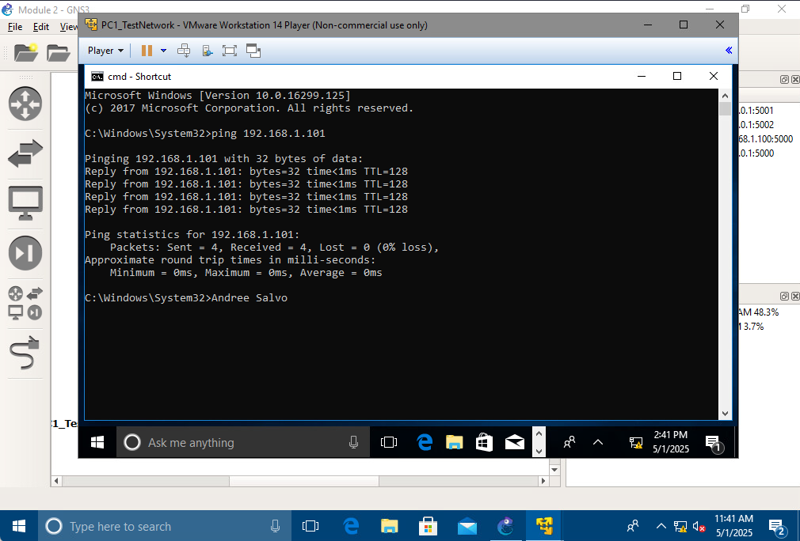
From PC1_TestNetwork to PC1_TestNetwork Gateway | 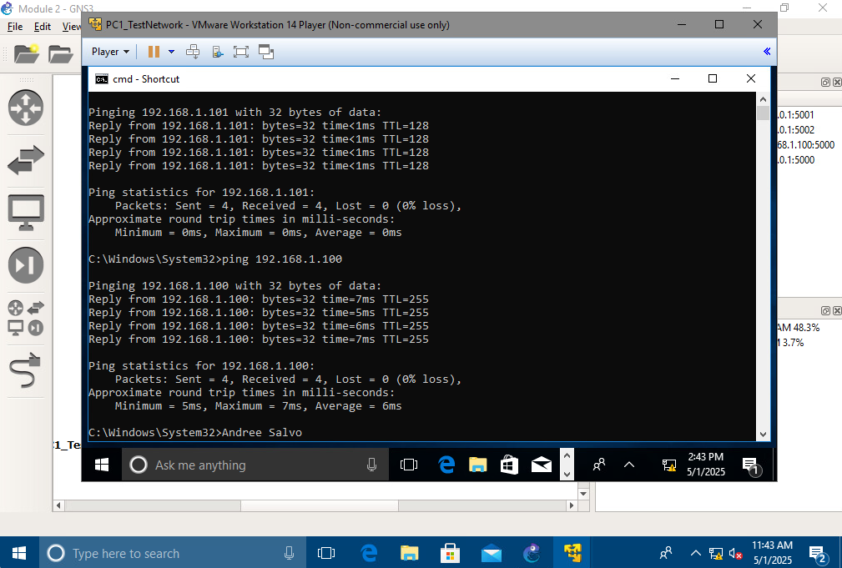
From PC1_TestNetwork to PC2_TestNetwork Gateway | 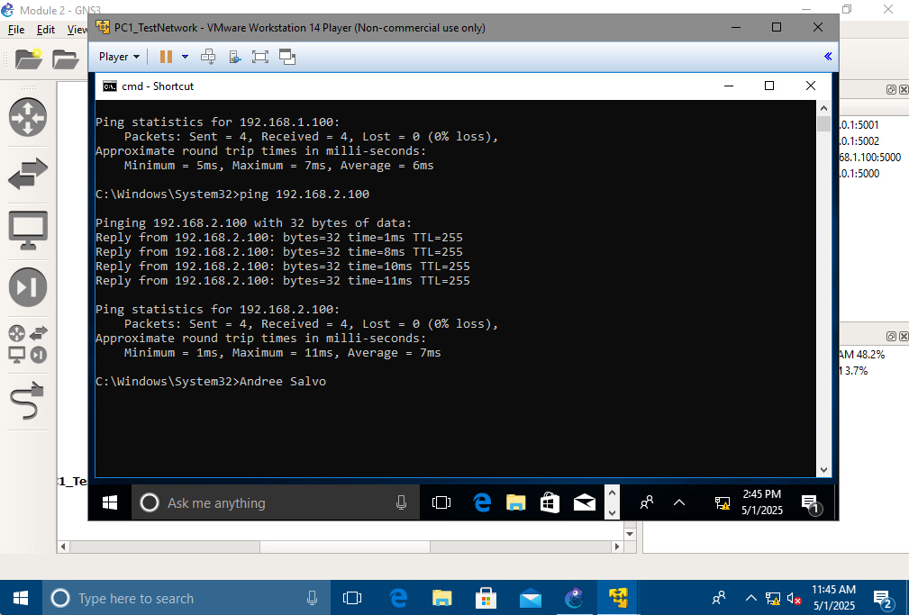
- From PC1_TestNetwork to PC2_TestNetwork | 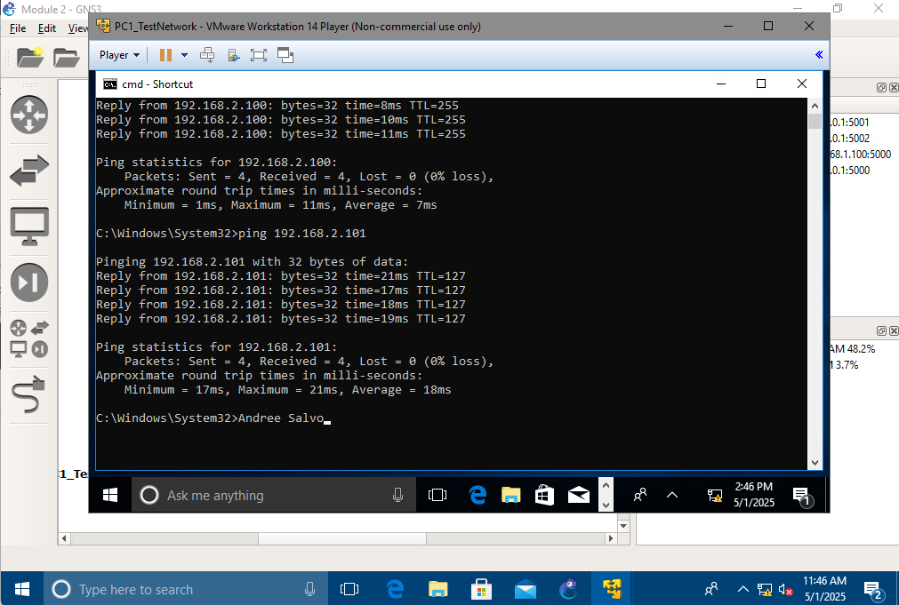

- Test connections for communications between the computers on the network. Submit screenshots of ping tests performed at the command line between devices on the network. The screenshots should show the results of executing the ping command between the following devices:
From PC2_TestNetwork to PC1_TestNetwork | 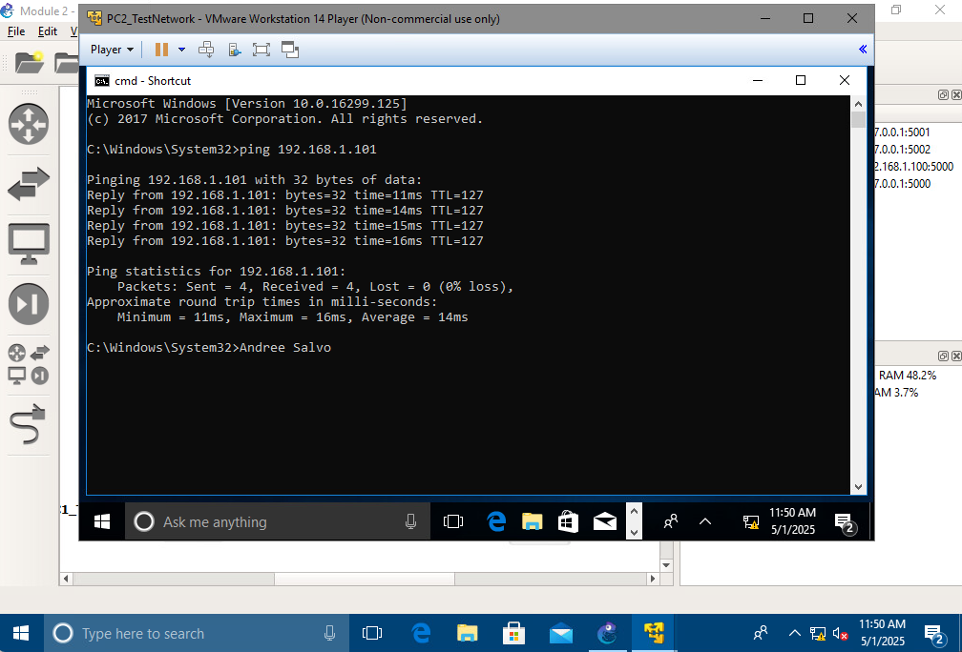
From PC2_TestNetwork to Server_TestNetwork | 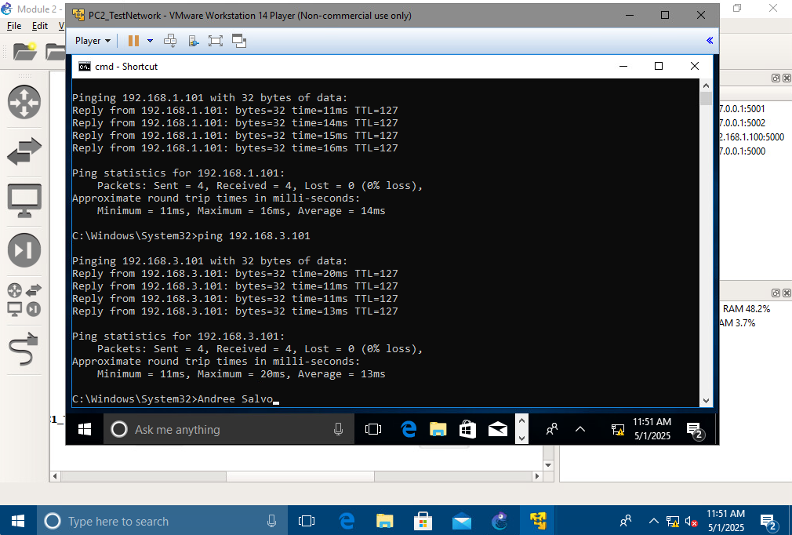
From Server_TestNetwork to PC1_TestNetwork | 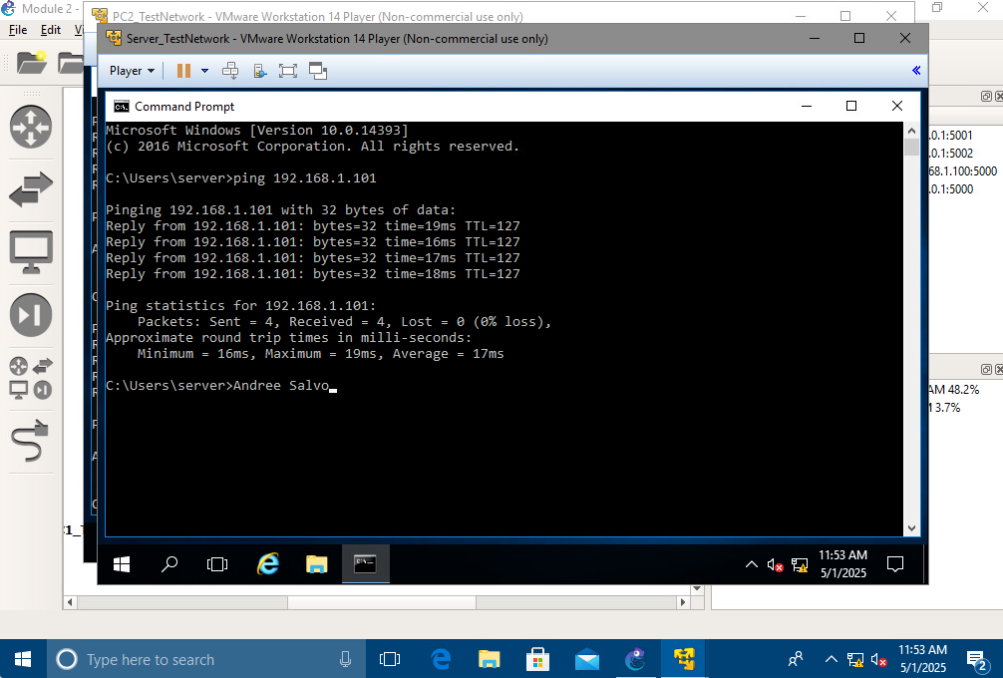
From Server_TestNetwork to PC2_TestNetwork | 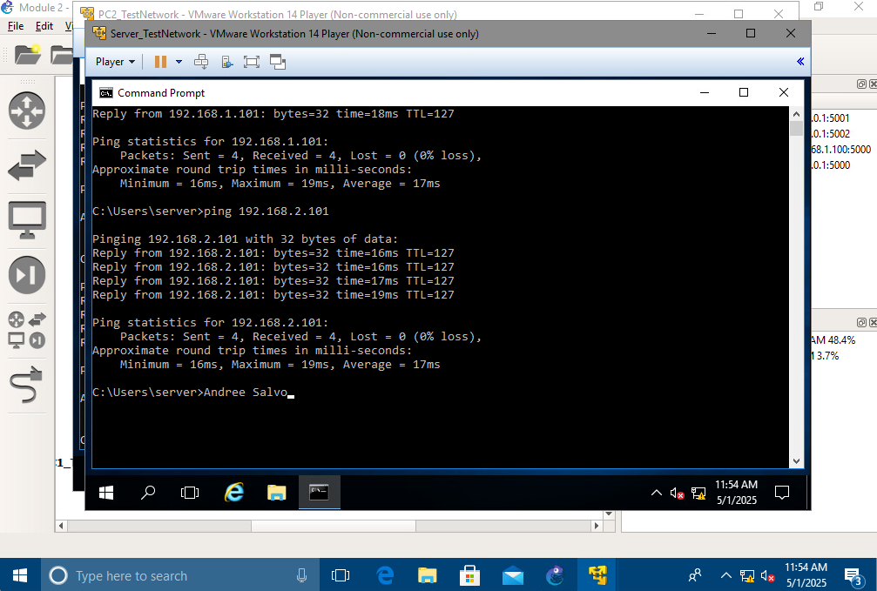
From PC1_TestNetwork to Server_TestNetwork | 